**What is Terraform?**

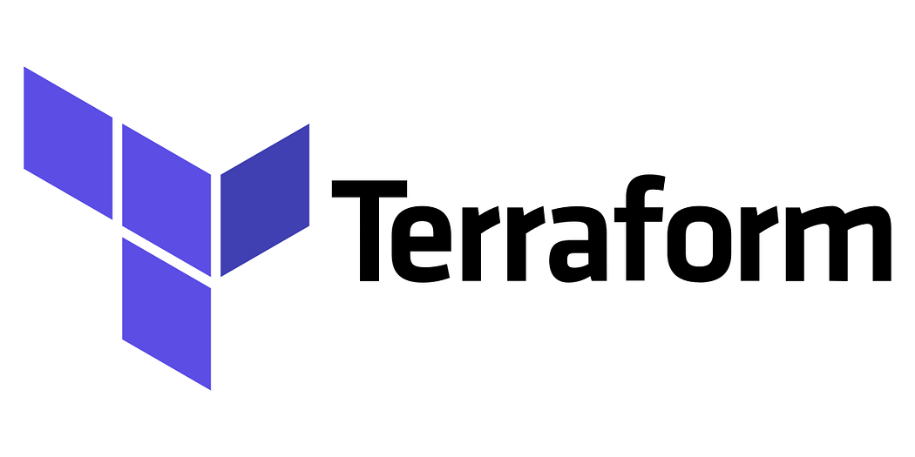

Terraform is a tool for building, changing, and versioning infrastructure safely and efficiently. It can manage popular service providers as well as custom in-house solutions.

One of the key features of Terraform is its ability to describe infrastructure as code. This means that infrastructure can be versioned, reviewed, and collaborated on just like software code. Additionally, Terraform allows for the reuse of infrastructure code across multiple projects and environments, making it easy to manage infrastructure at scale.

Using Terraform, you can create “infrastructure as code” files that define the resources you want to create. These files are written in the HashiCorp Configuration Language (HCL). Here’s an example of a simple Terraform configuration file that creates an Amazon Web Services (AWS) S3 bucket:

resource "aws_s3_bucket" "example" {  
 bucket = "example-bucket"  
}

Once you have your configuration files in place, you can use the Terraform command-line tool to preview and create your resources. For example, to create the S3 bucket defined in the example above, you would run the command terraform apply. Terraform will then communicate with the AWS API to create the specified S3 bucket.

One of the benefits of using Terraform is that it keeps track of the state of your resources. It knows what resources exist and what their current configuration is. This means that if you make changes to your Terraform configuration files and re-run the terraform apply command, Terraform will know what changes need to be made to bring your infrastructure up-to-date with the new configuration.

Another great feature of Terraform is that it allows for modularity and organization of your infrastructure code. For example, you can create multiple Terraform modules, each responsible for managing a specific part of your infrastructure. This allows you to better organize your code and make it more reusable across different projects.

Terraform also has the ability to manage existing infrastructure, which can save time and effort when migrating to infrastructure as code. With the use of import command, Terraform can import existing resources into its state and start managing them, thus also improving the collaboration between different teams as they can seamlessly work together with the provisioned resources. Another important feature of Terraform is its ability to create and manage dependant resources with the help of Terraform modules. These modules allow to split complex infrastructures into smaller, reusable, and independent parts which can be shared and versioned across teams.

Additionally, it also support cloud agnosticism and many providers, which makes it easier to manage multi-cloud infrastructure. Overall, Terraform provides a powerful and efficient solution for managing infrastructure as code, making it a great choice for organizations of all sizes.

In summary, Terraform is a powerful tool that allows for the efficient management of infrastructure as code. It allows for the creation and modification of resources across multiple providers, and it keeps track of the state of your resources. It also allows for modularity, reusability, and collaboration on infrastructure code making it a popular choice for infrastructure provisioning and management.